Design and apply context-aware access controls based on user identity, device posture, location, and application risk.

S.No | NAME | COLLEGE NAME | CONTACT
1. | DHANUJA SHRI S | SRI KRISHNA ADITHYA COLLEGE OF ARTS AND SCIENCE | 23bsca119dhanujashris@skacas.ac.in
2. | ATHIRA P | SRI KRISHNA ADITHYA COLLEGE OF ARTS AND SCIENCE | 23bsca113athirap@skacas.ac.in
3. | KAVIYA CM | SRI KRISHNA ADITHYA COLLEGE OF ARTS AND SCIENCE | 23bsca135kaviyacm@skacas.ac.in
4. | ABILASH U | SRI KRISHNA ADITHYA COLLEGE OF ARTS AND SCIENCE | 23bsca102abilashu@skacas.ac.in

Project details

Title: Design and apply context-aware access controls based on user identity, device posture, location, and application risk.

AI-Enhanced User Protection (AIUP)

In an era where the digital landscape is constantly evolving, organizations face an ever-increasing threat from cyberattacks. The need for swift and effective incident response has become paramount to safeguard sensitive data, protect digital assets, and maintain the trust of stakeholders. In response to this growing challenge, we present a visionary project: the development of an AI-driven incident response platform that empowers cybersecurity teams with the tools to automate and enhance incident triage and response tasks. The traditional network perimeter has all but dissolved in the modern digital landscape. With the mass adoption of cloud services, remote work, and personal mobile devices (BYOD), corporate resources are no longer confined to a single office building. This shift has rendered the conventional "castle-and-moat" security model—where anyone inside the network is trusted by default—obsolete and dangerously insufficient. Modern organizations now face the complex challenge of securing access to sensitive data from a diverse and ever-changing array of locations, devices, and user environments. To address this, security strategies must evolve from static, location-centric models to dynamic, identity-centric frameworks that assess the risk of every access request in real-time. This project focuses on the design and implementation of a context-aware access control system to solve this exact challenge. By moving beyond simple username and password verification, this system will evaluate a rich set of contextual signals before granting access to applications and data. These signals include the user's identity and role, the security posture of their device (e.g., is it patched, encrypted, and managed?), their geographic location, and the inherent risk level of the application they are attempting to use. By analyzing these factors in unison, the system can make a granular, real-time decision: grant full access, restrict access to certain features, require step-up authentication (like multifactor authentication), or block the request entirely. For example, a trusted employee accessing a low-risk application from a secured corporate laptop on the office network might have a seamless login experience. Conversely, that same employee attempting to access a critical financial system from an unpatched personal device in a foreign country would be met with additional security challenges or be completely blocked. This intelligent, adaptive approach not only significantly reduces the attack surface and protects against compromised credentials but also enables a secure and productive work environment for a modern, mobile workforce.

Abstract:

The increasing adoption of cloud services, mobile computing, and hybrid work models has fundamentally broken the traditional network perimeter, rendering legacy access control models ineffective. Organizations now struggle to protect sensitive data from a growing attack surface, where threats can originate from compromised endpoints, unsafe locations, or malicious insiders. Static, binary decisions (allow or deny) are no longer sufficient to mitigate the sophisticated risks present in modern distributed environments. There is a critical need for a dynamic security framework that can evaluate the full context of every access request in real-time. This project presents the design and application of a context-aware access control system based on user identity, device posture, geolocation, and application risk. The objective is to develop a policy engine that ingests multiple contextual signals to calculate a real-time risk score for each access attempt. The methodology involves defining granular policies that map specific context combinations (e.g., "managed device" + "corporate network" + "low-risk app") to corresponding access decisions, such as granting full access, enforcing step-up authentication (MFA), limiting session functionality, or denying access entirely. The expected outcome is an adaptive security model that significantly reduces the organizational attack surface and mitigates the risk of credential compromise. By ensuring that access decisions are dynamically aligned with the perceived threat level of each request, the system enhances security without introducing unnecessary friction for low-risk, trusted users. This approach provides a robust framework for enabling secure and productive access to resources in an increasingly perimeter-less and dynamic digital world.

Use Case Scenarios:

Scenario 1:

Finance Department Access to ERP System A senior accountant in the finance department needs to access the corporate Enterprise Resource Planning (ERP) system to process monthly payroll. The user connects from a remote location using their company-managed laptop. Upon launching the ZPA Client Connector, they authenticate via Azure Active Directory with multi-factor authentication (MFA). ZPA evaluates the user's identity, group membership (Finance_ ERP_ Users), device posture (antivirus active, disk encryption enabled), and connection context. The policy engine determines that the user is authorized and brokers a secure, direct micro-tunnel to the ERP application only. The user can interact with the ERP interface, but has no visibility or network-level access to any other internal systems, such as development servers or the HR database.

Output:

• User authenticated and authorized based on identity and group membership • Direct micro-tunnel established specifically to the ERP application

• All other internal applications and network segments remain invisible and inaccessible

Scenario 2:

Contractor Access to Specific Project Repository An external software consultant is hired for a three-month project and requires access only to a specific Git repository hosted on an internal server. The contractor is onboarded as a guest user in the identity provider and assigned to the "Project_ X_ Contractors" group. When the contractor connects using the ZPA client, the system verifies their identity and checks the device for basic security compliance (OS patch level, firewall enabled). ZPA enforces a policy that grants access exclusively to the Git repository application (port 22/SSH or port 443/HTTPS) during business hours (9 AM to 5 PM). The contractor can clone, push, and pull code, but cannot discover or connect to any other internal resources, including the corporate intranet or file servers.

Output:

• Time-bound and role-specific access enforced • Contractor restricted to a single application (Git repository) • Lateral movement to adjacent systems completely blocked

Scenario 3:

Executive Access to Sensitive Financial Documents A company VP needs to access a folder containing confidential M&A documents stored in a corporate SharePoint site. The user connects from a hotel business center while traveling internationally, using their company managed tablet. Upon launching the ZPA Client Connector, they authenticate via Azure Active Directory with MFA. ZPA evaluates the user's identity, executive group membership, and device posture (which is compliant). However, the geolocation (unusual foreign country) and the application risk (highly sensitive document repository) trigger an elevated risk score. The policy engine grants access to the SharePoint site, but enforces additional restrictions: download and print capabilities are disabled, and the session is monitored for unusual behavior (e.g., mass download attempts). An alert is also sent to the security team for high-risk executive login.

Output:

• User authenticated with MFA and device compliant, but flagged for unusual location

• Read-only access granted with download/print restrictions enforced

• Security team alerted to potential credential misuse or espionage attempt

Scenario 4:

Remote Support Technician Access to Internal Tools An IT support technician needs to access the corporate ServiceNow instance and a remote desktop tool to assist an employee. The technician connects from their home office using a company-managed desktop. Upon launching the ZPA Client Connector, they authenticate via Azure Active Directory with MFA. ZPA evaluates the user's identity, group membership

(IT_Support), device posture (fully compliant), and connection type (home office, which is whitelisted for IT staff). Because the user, device, and location all meet the baseline, the policy engine grants direct micro-tunnel access to both ServiceNow and the specific remote desktop jump host used for employee support. The technician can perform their duties efficiently, but still has no access to finance systems, HR databases, or source code repositories.

Output:

• User authenticated and fully authorized based on trusted context

• Direct micro-tunnels established to ServiceNow and the remote desktop jump host

• Least-privilege access maintained; unrelated internal systems remain invisible

Scenario 5:

High-Risk Application Access from a Low-Trust Location A marketing coordinator needs to access the corporate Salesforce instance to update a campaign. The user connects from a coffee shop using their company-managed smartphone. Upon launching the ZPA Client Connector, they authenticate via Azure Active Directory with MFA. ZPA evaluates the user's identity, group membership (Marketing Salesforce_ Users), device posture (managed and compliant), but flags the public Wi-Fi network as a high-risk connection. The policy engine determines that while the user and device are trusted, the network environment introduces unacceptable risk for direct access to a customer-facing CRM containing sensitive lead data. Instead of blocking access entirely, the user is routed through a secure ZPA browser isolation service, rendering the Salesforce session in a disposable container that prevents any data from persisting on the device or being exposed to the public network.

Output:

• User authenticated and device compliant, but network location deemed high-risk

• Access granted via browser isolation to prevent data leakage on public Wi-Fi

• Session is rendered in a secure container with copy/paste and download controls enforced

Stage-1

Title Of the Project: -

Design and apply context-aware access controls based on user identity, device posture, location, and application risk.
Overview:
In response to the evolving threat landscape and the dissolution of the traditional network perimeter, modern enterprises are rapidly shifting away from legacy VPN-centric remote access models. These conventional approaches often grant excessive network-level access, creating a significant attack surface and increasing the risk of lateral threat movement.
To address these challenges, this project centers on the implementation of a Zero Trust security architecture, fundamentally operating on the principle of "never trust, always verify." By moving beyond location-based access, we aim to establish a security posture where trust is no longer implicit, and access is determined by granular context rather than network connectivity. The core of this initiative involves the deployment of Zscaler Private Access (ZPA), a cloud-delivered Zero Trust Access solution designed to create identity-aware, application-specific connectivity.
Unlike traditional VPNs that place users on the internal network, ZPA leverages a "service-initiated" model to establish direct, one-to-one connections between authorized users and specific applications, completely hiding the corporate network and IP address space from the internet. This ensures that users connect exclusively to the applications they are permitted to access, based on continuous identity verification and context, rendering the applications invisible to unauthorized users and preventing common attack vectors such as port scanning and distributed denial-of-service (DDoS) attacks.
Ultimately, this project will enforce a least-privilege access model, ensuring users and devices are granted the minimum required access necessary to perform their functions. By decoupling application access from network access, we will eliminate the risk of lateral movement across the network, as users have no visibility or connectivity to other hosts. This strategic move not only significantly enhances security by reducing the attack surface but also simplifies the user experience and reduces operational overhead associated with legacy remote access infrastructure, positioning the organization at the forefront of secure and efficient access management

List of Vulnerability Table:

S.no | Vulnerability Name | CWE - No
1 | Improper Ownership Management | CWE-282
2 | Clear text Storage of Sensitive Information in a Cookie | CWE-315
3 | Use of Unmaintained Third Party Components | CWE-1104
4 | Insufficient Entropy | CWE-331
5 | Unchecked Error Condition | CWE-391
6 | Embedded Malicious Code | CWE-506
7 | Missing Encryption of Sensitive Data | CWE-311
8 | Missing XML Validation | CWE-112
9 | Missing Critical Step in Authentication | CWE-304
10 | Insufficient Logging | CWE-778

REPORT: -

Vulnerability Name: Improper Ownership Management

CWE/CVE: CWE-282

OWASP/SANS Category: A01:2025-Broken Access Control

Description: Improper Ownership Management occurs when a system fails to correctly assign or enforce ownership permissions for resources such as files, applications, or data. In such situations, unauthorized users may gain the ability to access, modify, or delete resources that should be restricted to specific owners or administrators. This vulnerability often arises due to incorrect configuration of access controls, weak permission management, or improper handling of user roles and privileges. Attackers may exploit this weakness to manipulate ownership settings, leading to unauthorized control over critical system resources.
Business Impact: If ownership management is not properly enforced, attackers or unauthorized users may gain access to sensitive resources and perform actions that compromise system integrity. This can result in unauthorized modification or deletion of important data, disruption of business operations, and potential data breaches. Additionally, organizations may face financial losses, legal consequences, and reputational damage if sensitive information or critical systems are compromised due to improper access control mechanisms.
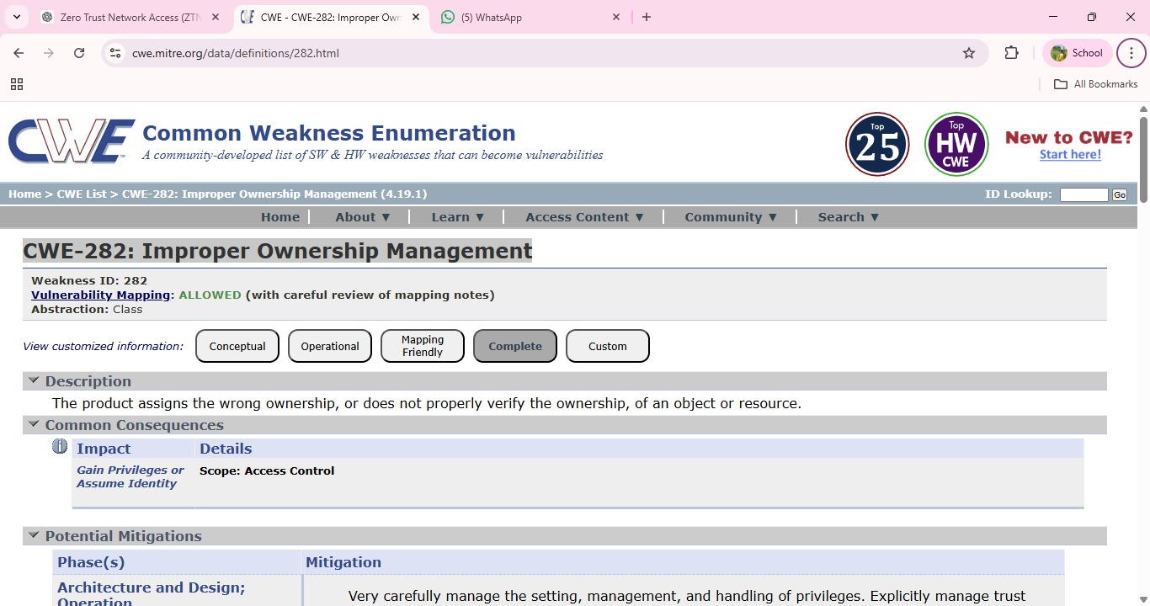

Vulnerability Name: Cleartext Storage of Sensitive Information in a Cookie

CWE/CVE: CWE-315

OWASP/SANS Category: A02:2025-Security Misconfiguration

Description: Cleartext Storage of Sensitive Information in a Cookie occurs when an application stores confidential data such as user credentials, session identifiers, or personal information in browser cookies without encryption. Since cookies are stored on the client side, they can be accessed by attackers through browser vulnerabilities, cross-site scripting (XSS) attacks, or by intercepting network traffic. If sensitive information is stored in plain text, attackers can easily read and misuse the data to gain unauthorized access to user accounts or application resources.
Business Impact: Storing sensitive information in cleartext cookies can lead to serious security risks such as session hijacking, unauthorized account access, and data breaches. Attackers may impersonate legitimate users and gain access to confidential information or internal systems. This can result in financial loss, legal liabilities, and damage to the organization's reputation, especially if customer or employee data is exposed.

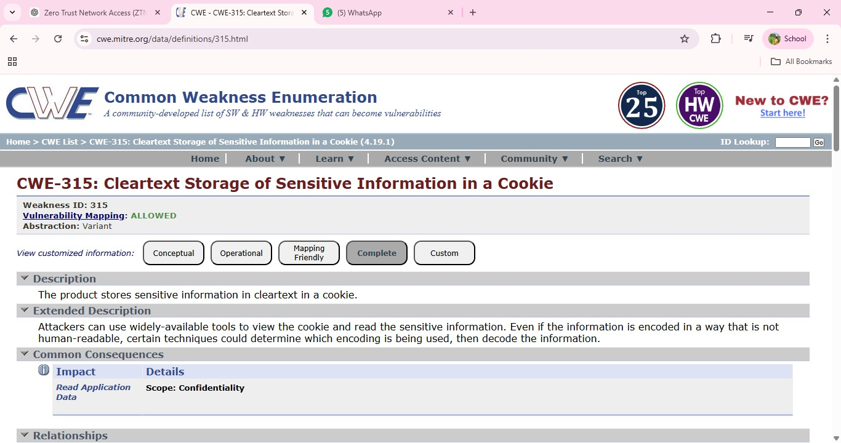

Vulnerability Name: Use of Unmaintained Third Party Components

CWE/CVE: CWE-1104

OWASP/SANS Category: A03 :2025-Software Supply Chain Failures

Description: Use of Unmaintained Third Party Components occurs when an application depends on external libraries, frameworks, or software components that are no longer actively maintained or updated by their developers. These outdated components may contain known security vulnerabilities that remain unpatched, making the application susceptible to exploitation. Attackers often scan systems for such components and exploit their weaknesses to gain unauthorized access, execute malicious code, or compromise the system.
Business Impact: Using unmaintained third-party components can expose an organization to significant security risks. Attackers may exploit known vulnerabilities to compromise applications, leading to data breaches, service disruptions, or unauthorized system access. This can result in financial losses, regulatory compliance issues, and damage to the organization's reputation. Maintaining updated and supported software components is therefore essential for ensuring long-term system security.

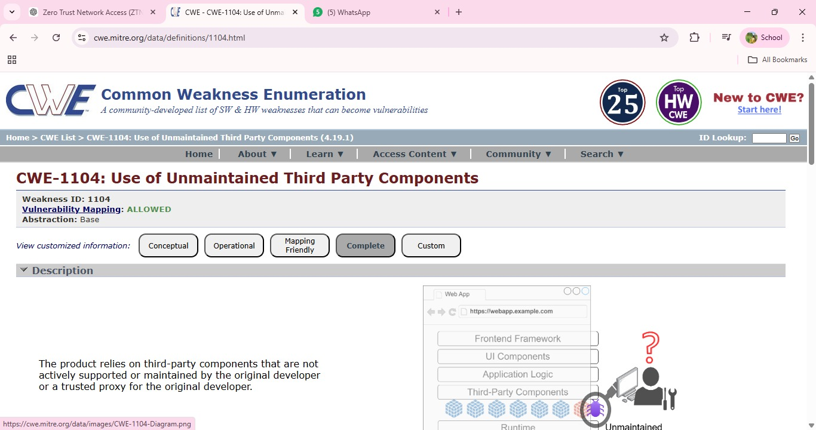

- Vulnerability Name: Insufficient Entropy
CWE/CVE: CWE-331
OWASP/SANS Category: A04 :2025-Cryptographic Failures

Description: Insufficient Entropy occurs when a system generates random values, such as cryptographic keys, session IDs, or tokens, using weak or predictable sources of randomness. Entropy refers to the level of unpredictability in generated values. When entropy is insufficient, attackers may be able to predict or reproduce these values, allowing them to bypass security mechanisms. This vulnerability often appears in authentication systems, encryption processes, or session management where strong randomness is required to maintain security.

Business Impact: If attackers can predict security tokens, session identifiers, or cryptographic keys, they may gain unauthorized access to user accounts or sensitive systems.This can lead to session hijacking, data breaches, and unauthorized transactions. For organizations, such incidents may result in financial losses, legal consequences, and damage to customer trust and reputation. Ensuring strong random number generation is essential to maintain system security.

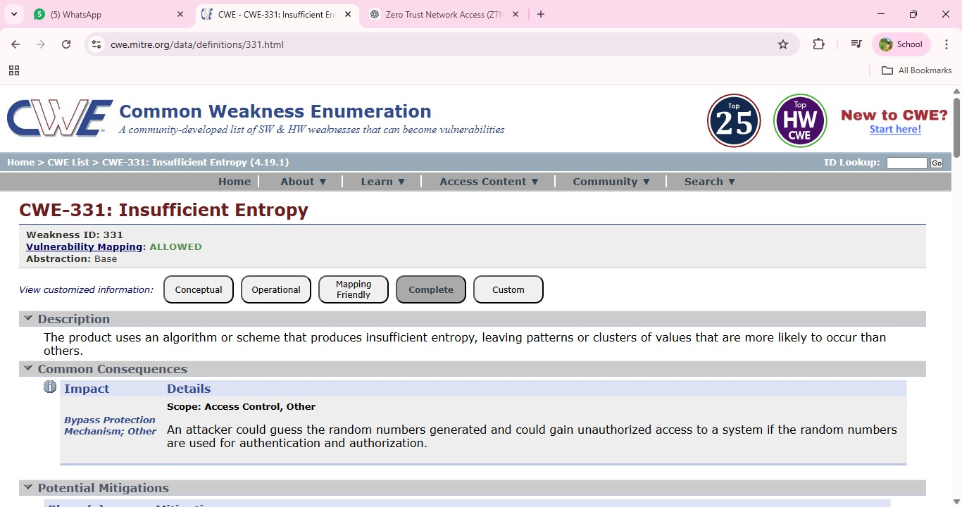

Vulnerability Name: Unchecked Error Condition

CWE/CVE: CWE-391
OWASP/SANS Category: A10 :2025-Mishandling of Exceptional Conditions

Description: Unchecked Error Condition occurs when a system or application fails to properly handle errors that occur during program execution. Instead of detecting and responding to these errors appropriately, the system may ignore them or continue processing without taking corrective action. This can lead to unexpected system behavior, incorrect outputs, or security weaknesses. Attackers may exploit such situations to trigger abnormal conditions, potentially bypassing security controls or causing the application to behave in unintended ways.
Business Impact: Failure to properly handle errors can result in system instability, data corruption, or unauthorized system behavior. Attackers may exploit these weaknesses to disrupt services, manipulate application functionality, or gain access to sensitive information. For organizations, this can lead to operational downtime, financial losses, and damage to reputation due to unreliable or insecure systems. Proper error handling and monitoring mechanisms are essential to maintain application reliability and security.

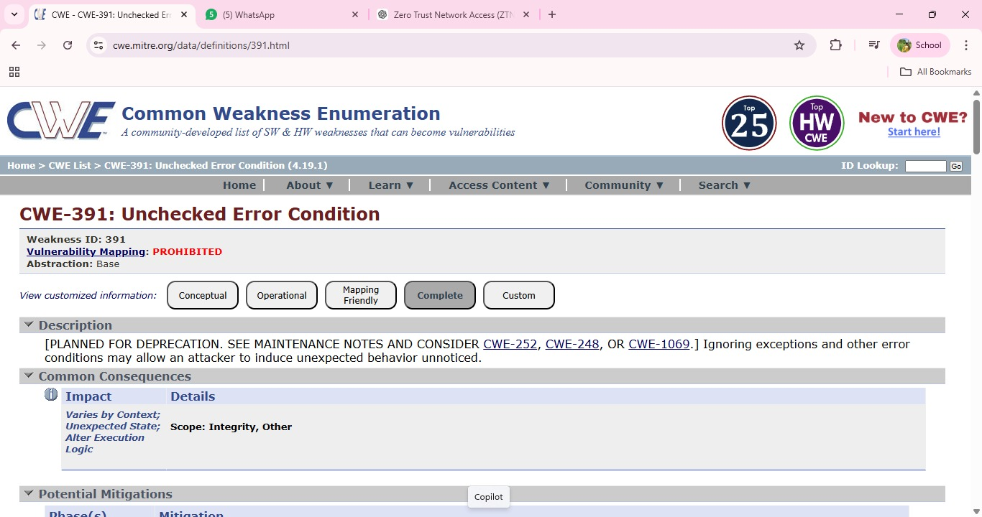
- Vulnerability Name: Embedded Malicious Code
CWE/CVE: CWE-506
OWASP/SANS Category: A08 :2025-Software or Data Integrity Failures

Description: Embedded Malicious Code refers to the presence of intentionally harmful code hidden within an application or software component. This malicious code may be inserted by attackers, compromised third-party libraries, or during insecure development practices. Such code can perform unauthorized actions such as stealing sensitive information, creating backdoors, or executing harmful operations without the user’s knowledge. Because the code is embedded within legitimate software, it may remain undetected for long periods and can be triggered under specific conditions.
Business Impact: The presence of embedded malicious code can severely compromise the security and reliability of an organization’s systems.Attackers may use it to steal confidential data, gain unauthorized access, or disrupt system operations. This can lead to data breaches, financial losses, operational downtime, and reputational damage. In critical environments, malicious code may also affect the integrity of applications and undermine trust in the organization’s software systems.
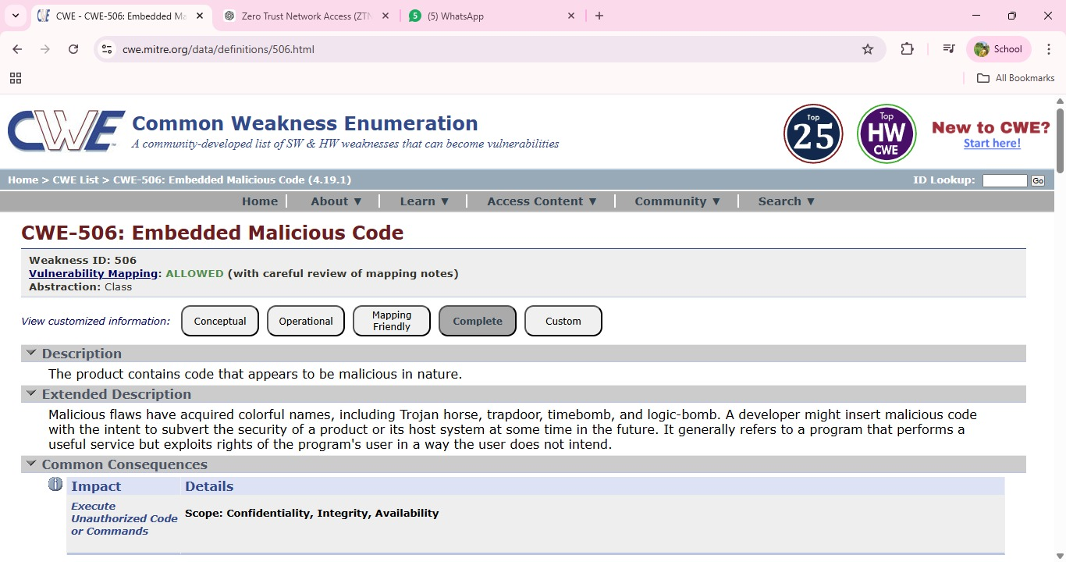

Vulnerability Name: Missing Encryption of Sensitive Data

CWE/CVE: CWE-311

OWASP/SANS Category: A06 :2025-Insecure Design

Description: Missing Encryption of Sensitive Data occurs when an application or system transmits or stores confidential information without using proper encryption mechanisms. Sensitive data such as user credentials, financial records, personal information, or internal system details may be exposed in plain text. If this data is intercepted during transmission or accessed by unauthorized users, attackers can easily read and misuse the information. This vulnerability often arises due to poor security configuration or failure to implement secure communication protocols.
Business Impact: Missing Encryption of Sensitive Data occurs when an application or system transmits or stores confidential information without using proper encryption mechanisms. Sensitive data such as user credentials, financial records, personal information, or internal system details may be exposed in plain text. If this data is intercepted during transmission or accessed by unauthorized users, attackers can easily read and misuse the information. This vulnerability often arises due to poor security configuration or failure to implement secure communication protocols.

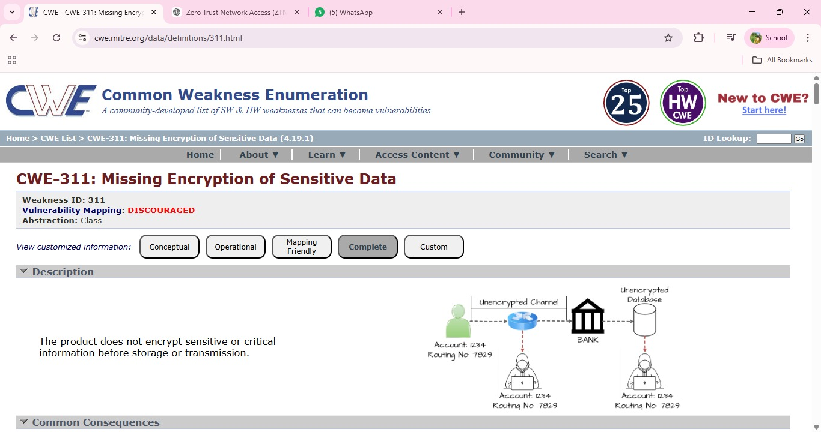

Vulnerability Name: Missing XML Validation

CWE/CVE: CWE-112

OWASP/SANS Category: A05 :2025-Injection

Description: Missing XML Validation occurs when an application processes XML input without properly validating its structure or content. XML is widely used for data exchange between systems, and if proper validation mechanisms are not implemented, attackers may send specially crafted XML data to manipulate application behavior. Without validation, the system may accept malicious or malformed XML input that can lead to security vulnerabilities such as XML injection, data manipulation, or unauthorized access to system resources.

Business Impact: If XML inputs are not properly validated, attackers may exploit this weakness to alter application data, bypass security checks, or disrupt normal system operations. This can lead to data integrity issues, service interruptions, and potential exposure of sensitive information.For organizations, such incidents may result in operational disruptions, financial losses, and reduced trust from customers or partners due to compromised system security.

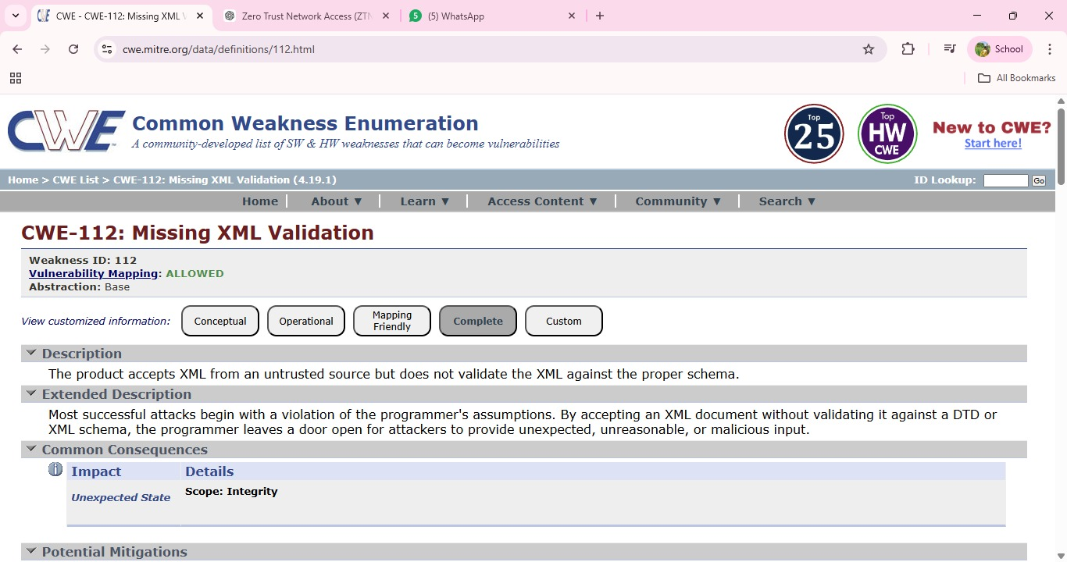

- Vulnerability Name: Missing Critical Step in Authentication
CWE/CVE: CWE-304
OWASP/SANS Category: A07 :2025-Authentication Failures

Description: Missing Critical Step in Authentication occurs when an application fails to enforce an essential step in the authentication process required to verify a user's identity. This may happen when security mechanisms such as multi-factor authentication, verification tokens, or session validation are skipped or improperly implemented. As a result, attackers may bypass authentication controls and gain unauthorized access to protected resources or user accounts. Such vulnerabilities often arise due to poor authentication logic or incomplete implementation of security checks.

Business Impact: If critical authentication steps are missing, attackers may successfully bypass login protections and gain unauthorized access to sensitive systems or user accounts.This can lead to data breaches, unauthorized transactions, and compromise of confidential information. For organizations, the impact may include financial losses, legal consequences, and damage to their reputation due to the failure to properly protect user authentication processes.

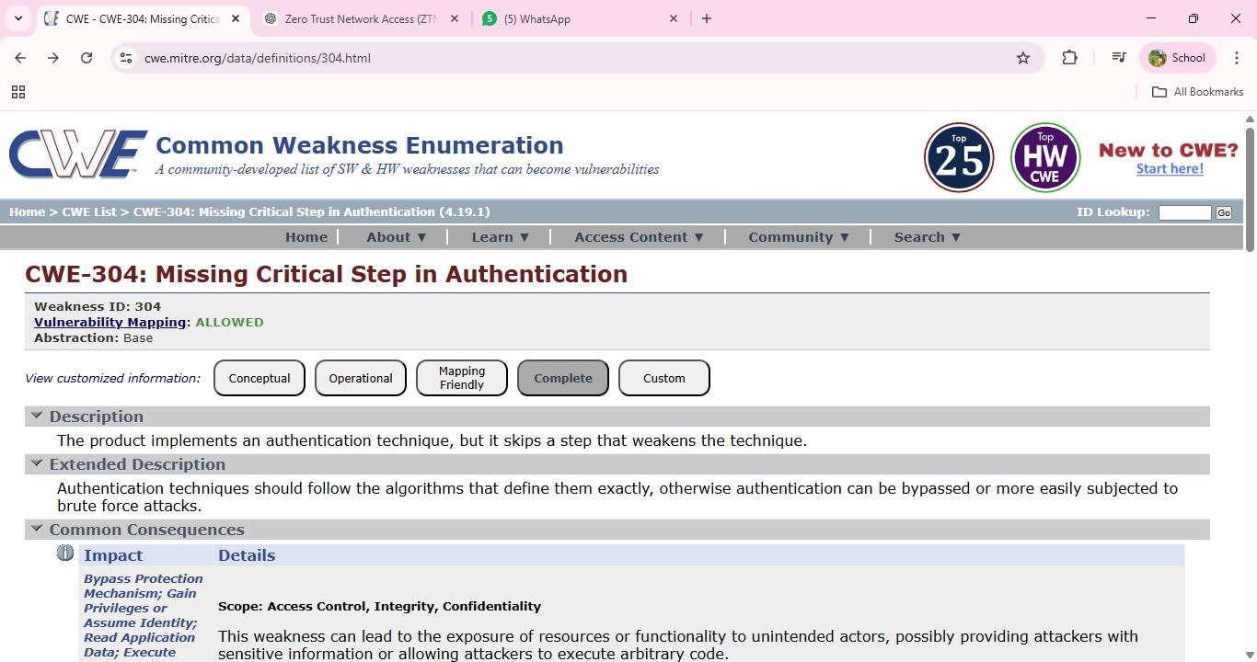

Vulnerability Name: Insufficient Logging

CWE/CVE: CWE-778

OWASP/SANS Category: A09 :2025-Security Logging and Alerting Failures

Description: Insufficient Logging occurs when an application or system fails to properly record security-related events such as login attempts, access requests, system errors, or configuration changes. Without adequate logging mechanisms, it becomes difficult to detect suspicious activities, unauthorized access attempts, or potential security breaches. Attackers may exploit this weakness to perform malicious actions without leaving sufficient evidence for administrators to identify or investigate the incident.
Business Impact: Lack of proper logging can significantly delay the detection of security incidents and make it difficult for organizations to respond effectively to cyber threats. Without accurate logs, identifying the source and impact of an attack becomes challenging, which may result in prolonged system compromise or data breaches. This can lead to operational disruptions, financial losses, regulatory compliance issues, and damage to the organization’s reputation.

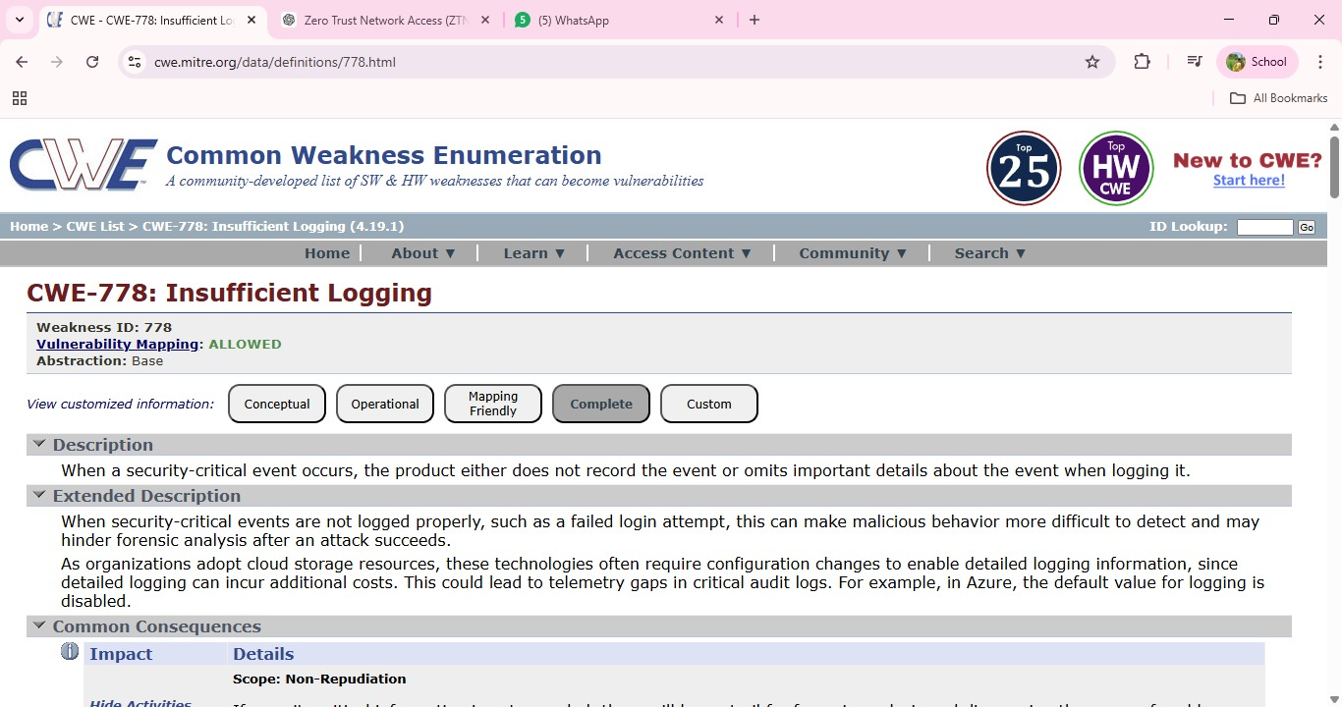

Stage 2

Overview :-

An overview of a Nessus scan typically involves the following key steps and aspects:
- Preparation: Define Objectives: Determine the scope and objectives of the scan. What systems or networks do you want to assess, and what specific vulnerabilities are you looking for? System
Access: Ensure that you have the necessary permissions and access rights to scan the target systems or networks.

- Configuration: Set Up Scan Policy:
Create a scan policy that defines the parameters of the scan, such as the types of vulnerabilities to check for, scanning frequency, and specific configurations. Define Target Assets: Specify the IP addresses, hostnames, or network ranges of the systems you want to scan.

- Scanning: Initiate Scan: Start the Nessus scan using the configured policy and target assets. Nessus will systematically scan the target systems for vulnerabilities based on its plugins and policies.

4. Vulnerability Identification: Nessus performs a comprehensive assessment, checking for vulnerabilities, misconfigurations, open ports, and other security issues. As the scan progresses, it categorizes vulnerabilities by severity, making it easier to prioritize remediation efforts.

5. Reporting: Nessus generates detailed reports that list the vulnerabilities discovered during the scan. Reports typically include information about the severity of each vulnerability, recommended actions for remediation, and supporting evidence. These reports can be customized and exported in various formats, such as PDF, HTML, or CSV.

6. Remediation: Review Findings: IT and security teams review the Nessus scan reports to prioritize and address the identified vulnerabilities. Remediation Steps: Take corrective actions to fix or mitigate the vulnerabilities. This may involve applying patches, changing configurations, or implementing security measures.

7. Follow-up: Regular Scanning: Conduct periodic Nessus scans to continuously monitor the security posture of the systems and networks. This helps identify new vulnerabilities and track progress in mitigating existing ones.
Integration: Integrate Nessus with other security tools or workflows to automate the vulnerability management process and streamline the response to new findings.

8. Compliance Auditing (if applicable): If compliance checks are part of your scan policy, review compliance results and take actions to ensure systems meet the required standards and regulations.

9. Documentation: Maintain records of scan results, remediation efforts, and compliance checks for audit and reporting purposes.

10. User Training: Ensure that your IT and security teams are trained in using Nessus effectively and interpreting scan results. Nessus scans are a critical component of proactive security, helping organizations identify and address vulnerabilities in their IT infrastructure to reduce the risk of security breaches and data compromises. The frequency and depth of scans can vary depending on an organization's security strategy and requirements. Nessus is a popular vulnerability scanning tool used for identifying security weaknesses in computer systems and networks. It is widely utilized by security professionals and organizations to assess the security posture of their systems and to proactively identify potential vulnerabilities that could be exploited by attackers.

Here's what I understand about Nessus scans:

- Vulnerability Assessment: Nessus performs a vulnerability assessment by scanning target systems or networks to identify security issues, such as missing patches, misconfigurations, weak passwords, and other potential weaknesses that could be exploited by attackers.

2. Network Scanning: Nessus can scan a wide range of network devices, including servers, routers, switches, firewalls, and more. It examines network services, open ports, and software running on target systems.

3. Plugin Architecture: Nessus uses a plugin-based architecture, allowing it to check for a wide variety of vulnerabilities. These plugins are regularly updated to include the latest security checks and support for new vulnerabilities.

4. Compliance Auditing: It can also be used to assess systems against various compliance standards and regulatory requirements, helping organizations ensure that their systems meet specific security standards, like PCI DSS or CIS benchmarks.

5. Customization: Nessus scans can be customized to suit the specific needs of an organization. Users can define scan policies, select the target systems, and specify the types of vulnerabilities to scan for.

6. Reporting: Nessus provides detailed reports that highlight vulnerabilities, their severity, and remediation recommendations. These reports are essential for IT and security teams to prioritize and address vulnerabilities.

7. Scanning Frequency: Organizations often perform regular Nessus scans to continuously monitor and improve their security posture. This is crucial for staying ahead of evolving threats and vulnerabilities.

8. Integration: Nessus can be integrated with other security tools and platforms, allowing organizations to automate the scanning process and streamline their vulnerability management.

9. Licensing: Nessus offers both free and commercial versions. The free version is limited in its functionality, while the commercial version provides more features and support.
10. User-Friendly Interface: Nessus offers an easy-to-use web-based interface, making it accessible to a wide range of users, from security experts to less experienced IT professionals. It's important to note that Nessus is a valuable tool for identifying vulnerabilities, but it doesn't fix these vulnerabilities itself. It's up to the organization's IT and security teams to take the necessary steps to remediate the identified issues to enhance their security. user secure communication between users and the server.
s.no | Vulnerability name | Severity | plugins
1 | TCP/IP Timestamps Supported | INFO | 25220
2 | Service Detection | INFO | 22964
3 | SSL / TLS Versions Supported | INFO | 56984
4 | TLS Version 1.3 Protocol Detection | INFO | 138330
5 | Additional DNS Hostnames | INFO | 46180
6 | TLS ALPN Supported Protocol  Enumeration | INFO | 84821
7 | Common Platform Enumeration  (CPE) | INFO | 45590
8 | Device Type | INFO | 54615
9 | OS Fingerprints Detected | INFO | 209654
10 | TLS Version 1.2 Protocol Detection | INFO | 136318

Target website :- http://testfire.net/
Target ip address:- 65.61.137.117

List of vulnerability:-

REPORT: -
1. Vulnerability Name : - 25220 - TCP/IP Timestamps Supported
Severity: INFO
Plugin: - 25220
Port: - N/A
Description: - The remote host supports TCP timestamps as defined in RFC1323. This
feature is used to improve network performance and reliability by helping with round-trip time
calculations and protection against wrapped sequence numbers. However, a side effect of TCP
timestamps is that an attacker may be able to estimate the uptime of
the remote system. By analyzing timestamp values in TCP packets, it may be possible to
determine how long the system has been running since its last reboot.

Solution: -
If the exposure of system uptime information is a concern, administrators can disable TCP timestamps in
the operating system&#39;s network configuration. This can typically be done by modifying system network
settings or kernel parameters depending on the operating system in use. Disabling this feature may slightly
affect certain TCP performance optimizations
Business Impact:
This issue does not directly compromise the system or expose sensitive data. However, it can reveal system
uptime information, which may provide useful insights to attackers when performing reconnaissance on the
network. Understanding system uptime could help attackers plan targeted attacks or identify systems that
have not been recently restarted or updated. Proper configuration and monitoring can help minimize such
information exposure.

2. Vulnerability Name : - Service Detection
Plugin: - 22964
Port: - 80 / tcp / www
Description: - The scan detected the service running on the remote host by analyzing the
service banner or by examining the response returned when an HTTP request was sent. Banner
information or error messages from services may reveal details about the software, web server,
or application running on the target system. This information helps identify the type and version
of services operating on the host.
Solution: - Administrators can reduce information exposure by configuring services to hide or limit banner
information and detailed error messages. Web servers and applications should be configured to suppress
version details and unnecessary system information. Regular updates and proper service configuration also
help minimize unnecessary information disclosure.

Business Impact: - This issue does not directly pose a security threat. However, exposed
service details can assist attackers during the reconnaissance phase by revealing information
about the technologies used in the system. Such information may help attackers identify
potential vulnerabilities associated with specific services or software versions. Proper
configuration helps reduce this information exposure and strengthens overall security posture.

3. Vulnerability Name : - SSL / TLS Versions Supported
Severity: - INFO
Plugin: - 56984
Port: - 443 / tcp / www
Description: - The scan identified the Secure Sockets Layer (SSL) and Transport Layer Security
(TLS) protocol versions supported by the remote service for encrypting communications. These
protocols are used to secure data transmitted between the client and the server. Detecting supported
SSL/TLS versions helps administrators understand which encryption protocols are enabled on the
server and whether they meet current security standards.
Solution: - Administrators should review the enabled SSL/TLS versions on the server and ensure that
only secure and up-to-date protocols are allowed. Older and insecure versions should be disabled to
maintain strong encryption standards. Regularly updating the server configuration and security settings
will help ensure that secure communication protocols are used.
Business Impact: - This information does not directly represent a vulnerability but reveals
which encryption protocols the server supports. Attackers could use this information during
reconnaissance to identify outdated or weak SSL/TLS versions if they are enabled. Ensuring that
only modern and secure protocols are supported helps maintain strong protection for data
transmitted over the network.

4. Vulnerability Name: - TLS Version 1.2 Protocol Detection
Severity: - INFO
Plugin: - 136318
Port: - 443 / tcp / www

Description: - The scan detected that the remote service supports Transport Layer Security
(TLS) version 1.2 for encrypting communications. TLS 1.2 is a widely used cryptographic
protocol that helps secure data transmitted between clients and servers over the internet. This
detection simply confirms that the service can establish encrypted connections using TLS 1.2.
Solution: - Ensure that the server continues to support secure and up-to-date encryption protocols.
Administrators should verify that insecure protocols such as older SSL or TLS versions are disabled if
they are not required. Regular updates and proper configuration of SSL/TLS settings help maintain strong
communication security.
Business Impact: - This finding is informational and does not indicate a direct vulnerability.
The presence of TLS 1.2 support confirms that the server is capable of providing secure
encrypted communication. Proper management of supported protocols ensures that data
transmitted between users and the server remains protected from interception.

5. Vulnerability Name: - 46180 - Additional DNS
Hostnames
Severity: - INFO
Plugin: - 46180
Port: - 0
Description: - Hostnames different from the current hostname have been collected by
miscellaneous plugins. Nessus has generated a list of hostnames that point to the remote host.
Note that these are only the alternate hostnames for hosts discovered on a web server.

Different web servers may be hosted on name-based virtual hosts.
Solution: - If you want to test them, re-scan using the special vhost syntax, such as :
www.example.com [192.0.32.10]
Business Impact: -This does not pose an immediate threat to business operations or data
security. It indicates the discovery of hostnames that are associated with the remote host,
particularly in cases of web servers utilizing name-based virtual hosts. While not a security risk
on its own, it could be useful for understanding the server&#39;s configuration and infrastructure.
Organizations should consider this information as part of their network documentation but do not
need to take immediate action to mitigate it as a security threat.

6. Vulnerability Name:-TLS ALPN Supported Protocol
Enumeration
Severity: - INFO
Plugin: - 84821
Port: - 443 / tcp / www
Description: The scan detected that the remote host supports the Application-Layer Protocol Negotiation
(ALPN) extension in TLS. ALPN allows the client and server to negotiate which application-layer
protocol should be used during the TLS connection, such as HTTP/1.1 or HTTP/2. This plugin
enumerates the protocols supported by the ALPN extension on the remote service.
Solution: - Administrators should review the protocols supported by the ALPN extension and ensure that
only necessary and secure protocols are enabled. Disabling unused or outdated protocols can help reduce
unnecessary information exposure and improve the security configuration of the server. Regular updates and
proper server configuration are also recommended.
Business Impact: - This finding is informational and does not indicate a direct security risk.
However, the disclosure of supported protocols may provide useful information to attackers
during the reconnaissance phase. Understanding which protocols are enabled on a server could
help attackers identify potential weaknesses if outdated or insecure protocols are present. Proper
configuration and monitoring can help reduce this exposure.

7. Vulnerability Name: - 45590 - Common Platform Enumeration
(CPE)
Severity: - INFO
Plugin: - 4559

Port: - 0
Description: - By using information obtained from a Nessus scan, this plugin reports CPE
(Common Platform Enumeration) matches for various hardware and software products found on
a host.
Note that if an official CPE is not available for the product, this plugin computes the best
possible CPE based on the information available from the scan.
Solution: - n/a
Business Impact: - This provides insights into hardware and software products identified on a
host through a Nessus scan. It reports CPE matches, which are standardized identifiers for these
products. This information is valuable for asset management and inventory purposes. While it
doesn&#39;t signify a security threat, it aids administrators in understanding the components within
their network, contributing to effective resource management and facilitating future system
maintenance.

8. VulnerabilityName: - Device Type
Severity: - INFO
Plugin: - 54615
Port: - 0
Description: - Based on the remote operating system, it is possible to determine what the remote
system type is (eg: a printer, router, general-purpose computer, etc).
Solution: -
Business Impact: - It allows for the identification of the remote system type, such as a printer,
router, or general-purpose computer, based on the remote operating system. While this doesn&#39;t
pose a direct security threat, it offers valuable insights for network administrators to better
understand and classify the devices in their network. This information aids in network

management, optimization, and ensures that the right security measures are in place for each
device type.

9.Vulnerability Name: - OS Fingerprints Detected
Severity: - INFO
Plugin: - 209654
Port: - N/A
Description: - The scan detected operating system fingerprints from the remote host using
multiple remote probing techniques such as TCP/IP, SMB, HTTP, NTP, and SNMP. These
probes analyze how the system responds to network requests in order to identify characteristics
of the underlying operating system. While the most accurate result is reported in the OS
Identification plugin, this plugin lists all fingerprints that were detected during the scanning
process.
Solution: - Administrators can reduce the exposure of system fingerprint information by limiting
unnecessary network services and filtering external requests using firewalls or intrusion prevention systems.
Proper network configuration and regular system updates can also help reduce information disclosure about
the operating system.
Business Impact: - This finding is informational and does not represent a direct security
vulnerability. However, information about the operating system can assist attackers during
reconnaissance activities. Knowing the type of operating system may help attackers search for
known vulnerabilities related to that system. Limiting unnecessary information exposure can
improve the overall security posture of the network.

10.Vulnerability Name: - TLS Version 1.3 Protocol Detection
Severity: - INFO
Plugin: - 138330
Port: - 443 / tcp / www

Description: The scan detected that the remote service supports Transport Layer Security (TLS)
version 1.3 for encrypting network communications. TLS 1.3 is the latest and more secure version of the
TLS protocol, designed to provide stronger encryption, improved performance, and better protection
against modern security threats. This detection confirms that the server is capable of establishing secure
encrypted connections using TLS 1.3.
Solution: - Administrators should ensure that TLS 1.3 remains enabled and properly configured on the
server. It is also recommended to disable older and less secure protocols such as SSL and outdated TLS
versions if they are not required. Regular updates and proper configuration of encryption settings help
maintain strong communication security.
Business Impact: - This finding is informational and does not represent a security vulnerability.
Supporting TLS 1.3 is considered a good security practice because it provides stronger
encryption and better protection for data transmitted over the network. Proper management of
encryption protocols ensures secure communication between users and the server.

Report: -

Stage-3

Title: - Design and apply context-aware access controls based on user identity, device posture, location, and application risk.
Context-aware access controls represent the operational pinnacle of a Zero Trust architecture, moving beyond static rules to create a dynamic and adaptive security perimeter around every application. In a modern enterprise, where users are mobile, devices are diverse, and threats are sophisticated, granting access based solely on a username and password is a dangerous oversimplification. Designing and applying context-aware controls means building a policy engine that consumes multiple, real-time signals about an access request and renders an intelligent decision: to allow, to block, to limit, or to challenge. This approach ensures that the security posture is not a flat, always-on gate but a responsive system that tightens or loosens based on the risk of the specific moment. The design of such a system begins with a deep integration between the access broker, such as Zscaler Private Access (ZPA), and the organization's existing security and identity infrastructure. The first and most fundamental layer is user identity. This is not simply a username, but a rich set of attributes pulled from the corporate Identity Provider (IdP) like Azure AD or Okta. Integration via SAML ensures that when a user authenticates through the ZPA client, they are verified with multi-factor authentication (MFA) by the IdP. ZPA then ingests not just the user's name, but their group memberships (e.g., "Finance – Payroll Managers," "Engineering – Source Code Contributors"), roles, and department. This allows for the creation of granular policies that are intrinsically tied to the user's function within the organization. For instance, a policy can be written in plain language: "Allow members of the 'Finance-Payroll' group to access the 'ADP Payroll' application." However, a valid identity on a compromised device is still a critical threat. This is where the second layer, device posture, becomes essential. The design incorporates continuous checks on the security health of the endpoint attempting the connection. Through integrations with Endpoint Detection and Response (EDR) tools like CrowdStrike or SentinelOne, and Mobile Device Management (MDM) solutions like JAMF or Intune, ZPA can assess a device's real-time hygiene. The policy engine evaluates factors such as: Is the device's disk encryption (BitLocker/FileVault) enabled? Is the antivirus software active and its definition database up-to-date? Has the operating system been patched to the latest security baseline? Is the device rooted or jailbroken? Is there a high-risk score being reported by the EDR tool due to suspicious activity? If a device fails these checks—for example, a user's laptop has its firewall disabled—the context-aware policy can automatically trigger an action. It might block access entirely, or it might grant "remediation access," routing the user to a captive portal to download updates or contact IT, while preventing them from reaching any business-critical applications. This ensures that a vulnerable endpoint cannot become a beachhead for an attacker to move laterally into the corporate environment. The third contextual layer is location and network environment. The physical or virtual location from which a user connects provides a powerful signal for risk assessment. A finance director accessing the payroll system from their home office in the same city is a low-risk event. The same user attempting to connect from a country with a high prevalence of cybercrime, or from an anonymizing VPN service, should be treated with extreme suspicion. Context-aware policies can be designed to enforce this logic. For example, access to a source code repository containing intellectual property could be restricted to users connecting from a corporate office or a pre-approved home IP address range. If a legitimate user is traveling, the policy might allow access but require a step-up authentication, such as a hardware token, or grant only read-only permissions. This layer can also consider the security of the network itself; a connection from a public, unencrypted Wi-Fi hotspot might trigger stricter controls than one from a known, secure corporate network. The final and often most strategic layer is application risk. Not all applications are created equal, and their access policies should reflect their value and sensitivity. In the design phase, applications are categorized and tagged based on their risk profile. An internal wiki used for cafeteria menus would be classified as low-risk, whereas a customer database, a financial trading platform, or a source code repository would be classified as high or critical risk. This tagging allows policies to be layered and dynamic. A single user might have access to multiple applications, but the controls applied to each session will differ based on the application's risk. For the low-risk wiki, a valid user identity and a compliant device might be sufficient. However, for the high-risk financial platform, the policy engine might require all four layers to align: the user must be in a specific group, on a fully patched and managed device, connecting from a trusted location, and may even be subject to session recording or time-of-day restrictions. This ensures that security resources and scrutiny are applied proportionally to the actual risk, preventing "blanket" access and ensuring that the most valuable assets have the most robust defenses. In practice, applying these controls within ZPA means using the policy builder to create conditional statements. A policy might read: "Allow access to 'Application A' if User is in 'Group X' AND Device Posture is 'Compliant' AND Location is 'Not Restricted' AND Application Risk is 'Low'." Alternatively, a more complex policy for a critical application might be: "Allow access to 'Application B' if User is in 'Group Y' AND Device Posture is 'Highly Secure' AND Location is 'Corporate Network' AND Time is 'Business Hours', otherwise, if Location is 'Remote', require Step-Up Authentication." By combining these signals, the organization creates a security posture that is finely tuned, highly resilient, and fundamentally adaptive to the context of every single access attempt, thereby upholding the core Zero Trust principle of "never trust, always verify."
Conclusion:
Stage 1: In conclusion, web application testing is a crucial process that ensures the security, functionality, and reliability of web-based software. It involves a comprehensive evaluation of various aspects, including user interface, functionality, performance, and security to identify and rectify issues before they impact end-users. This process not only enhances the quality of web applications but also bolsters their resilience against potential threats and vulnerabilities. In an age where online services and applications are integral to our daily lives, effective web application testing is essential to deliver a seamless and secure user experience.
Stage 2: The Nessus report for the specific website has highlighted key security insights. It identified vulnerabilities, categorized by severity, with a focus on critical and high-risk issues that need immediate attention. Recommendations for addressing these vulnerabilities include patching, reconfiguration, and other security measures, with a priority on actions that can have the most significant impact. Compliance with industry standards and best practices is considered, ensuring alignment with recognized security benchmarks like OWASP guidelines. The report underscores the need for continuous monitoring, regular updates, and ongoing security efforts to maintain a strong security posture. In summary, the Nessus report offers a clear view of the website's security state, provides guidance on mitigating vulnerabilities, and stresses the importance of sustained vigilance against evolving threats.
Stage 3: The implementation of Zscaler Private Access marks a pivotal shift from a vulnerable, networkcentric security model to a resilient, identity-centric Zero Trust architecture. By enforcing leastprivilege access and rendering private applications invisible to the internet, this project effectively neutralizes the threats of lateral movement and network-based attacks. The solution not only fortifies the organization's security posture against modern cyber threats but also delivers a seamless and high-performance experience for a distributed workforce. Furthermore, the decoupling of access from the network simplifies IT operations, reduces dependency on legacy VPN infrastructure, and provides granular visibility into user-application interactions. Ultimately, this initiative establishes a future-ready foundation for secure digital transformation..
Future Scope:
Stage 1: future scope of web application testing The future scope of web application testing is promising and evolving rapidly, driven by the continuous growth of the internet and web-based applications. Here are some key aspects of its
future scope:
▪ Increased Demand: As more businesses and services move online, the demand for web applications continues to grow. This, in turn, increases the demand for web application testing to ensure security, reliability, and functionality.
▪ Advanced Technologies: The complexity of web applications is rising with the integration of advanced technologies like AI, IoT, and blockchain. Testing these cutting-edge applications will require specialized skills and tools.
▪ Security Emphasis: With the growing number of cyber threats and data breaches, security testing for web applications will become even more critical. Testers will need to focus on vulnerabilities, data protection, and compliance with regulations like GDPR.
▪ Mobile and Cross-Browser Testing: Mobile usage is on the rise, and web applications must be responsive and functional on various devices and browsers. Testing for cross-compatibility will be essential.
▪ Performance Testing: As user expectations for speed and performance increase, load testing, stress testing, and other performance testing types will be crucial to ensure web applications can handle traffic spikes.
Stage 2: future scope of the testing process you understood. The future scope of the web application testing process, particularly in terms of identifying vulnerabilities, is exceedingly promising due to the continuous growth of digital platforms, the escalating importance of cybersecurity, and the ever-evolving threat landscape. Here are some key aspects that highlight the prospective scope of web application testing for vulnerability discovery:
▪ AI-Driven Testing: The integration of artificial intelligence (AI) and machine learning (ML) into web application testing tools will revolutionize the way vulnerabilities are identified. AI algorithms can swiftly scan vast amounts of code and data to pinpoint vulnerabilities that might elude human testers.
▪ IoT and Mobile App Testing: With the proliferation of Internet of Things (IoT) devices and the increasing usage of mobile applications, the scope of web application testing will extend to encompass these areas. Ensuring the security of IoT devices and the interfaces they use will become critical.
▪ Blockchain and Cryptocurrency Security: As blockchain technology and cryptocurrencies continue to gain traction, security testing will be imperative to safeguard transactions and digital assets. Ensuring the robustness of blockchain-based applications will be a specialized niche in web application testing. Serverless Architectures: With the adoption of serverless computing, web application testing will need to adapt to assess the security of serverless functions and APIs. Ensuring that serverless components are free from vulnerabilities will be paramount.
▪ Container Security: As containerization technologies like Docker and Kubernetes become ubiquitous, web application testing will extend to cover container security. This includes ensuring that container images and orchestration configurations are free from vulnerabilities. Stage 3: future scope of Aware Access Control The successful deployment of ZPA lays the groundwork for a broader, more integrated security ecosystem. Future enhancements can be explored to further mature the organization's security capabilities:
▪ Integration with Zscaler Internet Access (ZIA): Converging Private Access (ZPA) with Internet Access (ZIA) to create a unified Secure Access Service Edge (SASE) platform, managing all web and private traffic through a single policy framework.
▪ Advanced Device Posture Checking: Moving beyond basic compliance to incorporate real-time risk scores from EDR tools, blocking access if a device shows signs of active compromise.
▪ Privileged Remote Access: Extending ZPA to third-party vendors and contractors with timebound, audited access to specific critical systems, replacing jump boxes and bastion hosts.
▪ IoT/OT Segmentation: Applying the same micro-tunneling principles to Internet of Things (IoT) and Operational Technology (OT) devices to ensure they can only communicate with specific management servers.
▪ AI-Driven Anomaly Detection: Leveraging machine learning on ZPA logs to detect behavioral anomalies, such as a user accessing an application at an unusual hour or from a strange location, triggering automated MFA challenges or access revocation.
▪ Cloud Workload Protection: Utilizing ZPA to secure connections between containers and microservices in multi-cloud environments (AWS, Azure, GCP), ensuring east-west traffic between workloads is encrypted and authenticated.

▪ Automated Provisioning/Deprovisioning: Enhancing the identity provider integration to automatically revoke application access the moment an employee is terminated or changes roles, ensuring near real-time access control.
▪ Digital Experience Monitoring (DEM): Implementing DEM tools to proactively monitor the enduser experience, identifying network latency or application performance issues before they impact productivity. Topics Explored:
1. Zscaler
2. Zero trust
3. ZPA
4. VPN
5. MISP
6. College Network Information
7. Deployment of SOC in the College
8. Threat Intelligence
9. Incident Response Tools Explored: ▪ Nessus Scanner

THE END

